LAB MANUAL
PART B

Roll No. C-60 | Name: Avdhut Madhavi
Class. SE-C | Batch: C2
Date of Experiment: | Date of Submission:
Grade:

B.1: Implement and trace the following programs. Write the code, compile/run it, and record the output after each task.
- Run the program with the items given in a different input order (e.g., reverse of the original order) and verify that the maximum value obtained remains the same.

#include <stdio.h>
#include <conio.h>

struct Item {
int weight;
int value;
float ratio;
};

void sortItems(struct Item items[], int n) {
int i, j;
struct Item temp;

for (i = 0; i < n - 1; i++) {
for (j = 0; j < n - i - 1; j++) {
if (items[j].ratio < items[j + 1].ratio) {
temp = items[j];
items[j] = items[j + 1];
items[j + 1] = temp;
}
}
}
}

float fractionalKnapsack(struct Item items[], int n, int W) {
int i, remaining;
float totalValue, fraction, addedValue;

totalValue = 0.0;
remaining = W;

for (i = 0; i < n; i++) {
items[i].ratio =
(float)items[i].value / items[i].weight;
}

sortItems(items, n);

printf("\nGreedy Selection Steps\n");
printf("Weight Value Ratio Fraction Added Remaining\n");

for (i = 0; i < n; i++) {
if (remaining == 0)
break;

if (items[i].weight <= remaining) {
totalValue = totalValue + items[i].value;
remaining = remaining - items[i].weight;

printf("%d %d %.2f Full(1.0) %d %d\n",
items[i].weight,
items[i].value,
items[i].ratio,
items[i].value,
remaining);
} else {
fraction = (float)remaining / items[i].weight;
addedValue = items[i].value * fraction;
totalValue = totalValue + addedValue;

printf("%d %d %.2f Partial(%.2f) %.2f 0\n",
items[i].weight,
items[i].value,
items[i].ratio,
fraction,
addedValue);

remaining = 0;
}
}

return totalValue;
}

void displayItems(struct Item items[], int n) {
int i;

printf("\nItems (Weight, Value):\n");

for (i = 0; i < n; i++) {
printf("Item %d: (%d, %d)\n",
i + 1, items[i].weight, items[i].value);
}
}

int main() {
struct Item items1[3] = {
{10, 60, 0.0},
{20, 100, 0.0},
{30, 120, 0.0}
};

struct Item items2[3] = {
{30, 120, 0.0},
{20, 100, 0.0},
{10, 60, 0.0}
};

struct Item items3[5] = {
{5, 30, 0.0},
{10, 40, 0.0},
{15, 45, 0.0},
{22, 77, 0.0},
{25, 90, 0.0}
};

float maxValue;
int n;

clrscr();

printf("TEST CASE 1: Original Order\n");
n = 3;
displayItems(items1, n);
printf("Knapsack Capacity: 50\n");
maxValue = fractionalKnapsack(items1, n, 50);
printf("Maximum Total Value: %.2f\n", maxValue);

printf("\nTEST CASE 2: Reverse Order\n");
n = 3;
displayItems(items2, n);
printf("Knapsack Capacity: 50\n");
maxValue = fractionalKnapsack(items2, n, 50);
printf("Maximum Total Value: %.2f\n", maxValue);

printf("\nTEST CASE 3: Random Items\n");
n = 5;
displayItems(items3, n);
printf("Knapsack Capacity: 60\n");
maxValue = fractionalKnapsack(items3, n, 60);
printf("Maximum Total Value: %.2f\n", maxValue);

printf("\nCOMPLEXITY ANALYSIS\n");
printf("Sorting: O(n^2)\n");
printf("Greedy selection: O(n)\n");
printf("Overall time complexity: O(n^2)\n");
printf("Auxiliary space: O(1), excluding input storage\n");

printf("\nCHARACTERISTICS\n");
printf("1. Selects highest value/weight ratio first.\n");
printf("2. Optimal for Fractional Knapsack.\n");
printf("3. Not always optimal for 0/1 Knapsack.\n");

getch();
return 0;
}

Output :

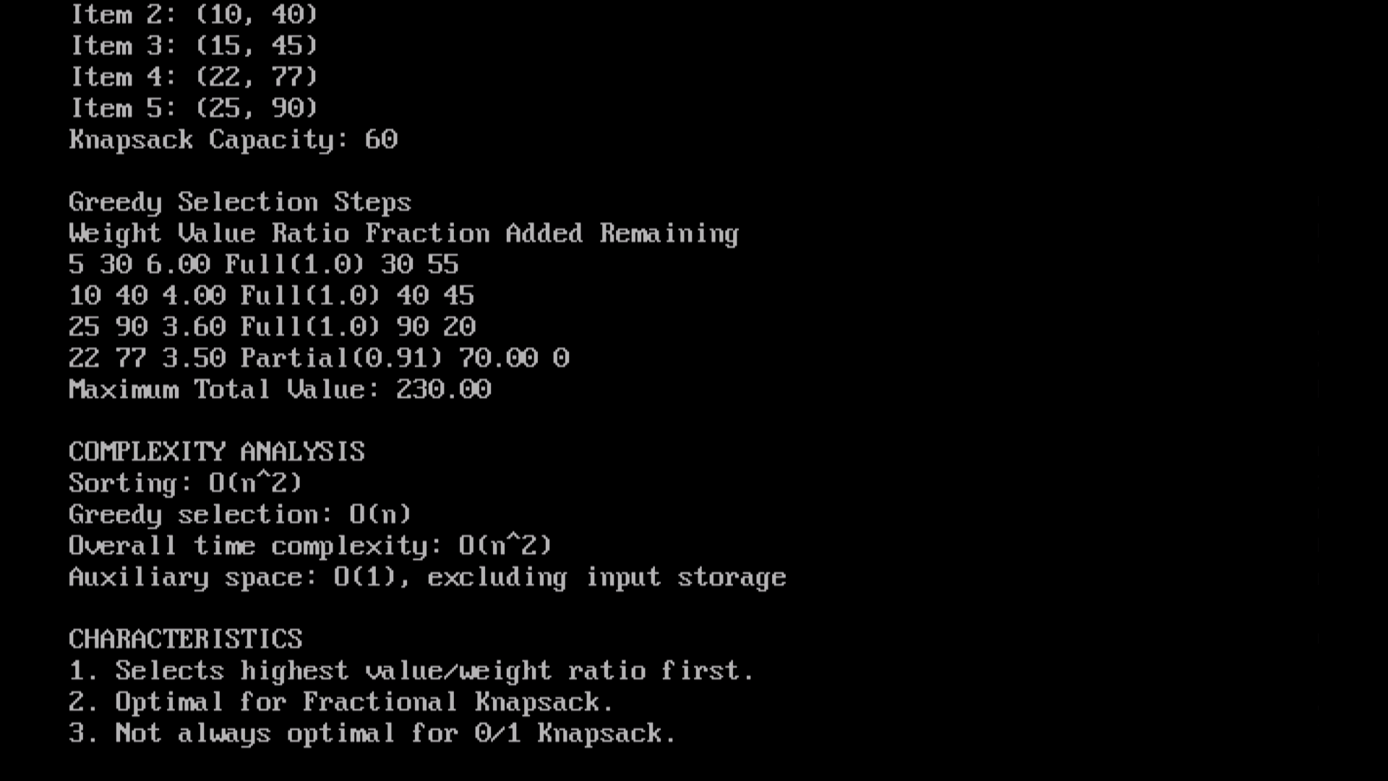

- Do the analysis of fractional knapsack problem
- The Fractional Knapsack problem is solved using the Greedy approach by selecting items with the highest value-to-weight ratio first.
- Items are sorted in descending order of their ratios before selection.
- If an item cannot fit completely, a fraction of it is selected to maximize the total value.
- The time complexity is $O\left(n^{2}\right)$using bubble sort, and the auxiliary space complexity is $O\left(1\right)$.
- The Greedy approach provides an optimal solution for the Fractional Knapsack problem.

